Mohammad Yehya Hayati

K213309@nu.edu.pk

PF Lab

Assignment #4

Table of Contents

**Question #1** 2

**Question #2** 3

**Question #3** 4

**Question #4** 5

**Question #5** 6

**Question #6** 7

**Question #7** 8

**Question #8** 9

# **Question #1**

#include <stdio.h>

#include <math.h>

int main(){

//Q1

int StdID,Courses;

int Fee = 15000;

printf("INPUT the student ID: ");

scanf("%d",&StdID);

printf("Input the total number of courses: ");

scanf("%d",&Courses);

printf("Cost of each course: %d", Fee);

printf("\n\nStudent ID = %d",StdID);

printf("\nTotal Amount = %d",Fee * Courses);

}

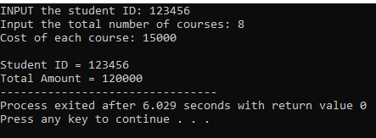

# **Question #2**

#include <stdio.h>

#include <math.h>

int main(){

//Q2

float Num1,Num2;

float Quo;

printf("Please enter two numbers\nNumber1 = ");

scanf("%f", &Num1);

printf("Number2 = ");

scanf("%f",&Num2);

Quo = Num1/Num2;

printf("The sum of the two numbers is = %f", Num1 + Num2);

printf("\nThe product of the two numbers is = %f", Num1*Num2);

printf("\nThe difference of the two numbers is = %f",Num1 - Num2);

printf("\nThe quotient of the two numbers is = %f", Quo);

printf("\nThe remainder of the two numbers is = %f",fmod(Num1,Num2));

}

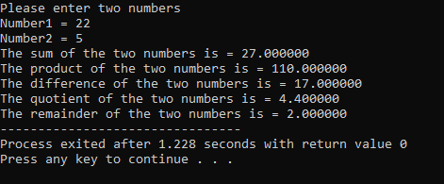

# **Question #3**

#include <stdio.h>

#include <math.h>

int main(){

//Q3

int x;

x = 7 + 3 * 6 / 2 - 1;

printf("First 6 is divided by 2 then the answer is multiplied by 3 and then added by 7 and -1\nThe number is %d",x) ;

x = 2 % 2 + 2 * 2 - 2 / 2;

printf("\nFirst 2 MOD 2 is done then 2*2 then 2/2 then all of them are added\nThe number is %d",x);

x = ( 3 * 9 * ( 3 + ( 9 * 3 / ( 3 ) ) ) );

printf("\nFirst the inner most bracket is solved and then the next bracket and so on\nThe number is %d",x);

}

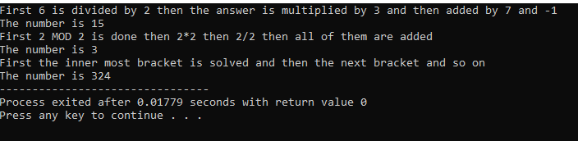

# **Question #4**

#include <stdio.h>

#include <math.h>

int main(){

//Q4

float Num;

printf("Please enter a number: ");

scanf("%f", &Num);

printf("The numbers are %.1f , %.1f , %.1f", Num , pow(Num,2) , pow(Num,3));

}

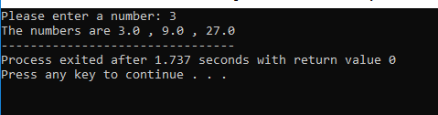

# **Question #5**

#include <stdio.h>

#include <math.h>

int main(){

//Q5

float S,a,t,u;

printf("Please enter the initial velocity of the object: ");

scanf("%f", &u);

printf("Please enter the acceleration of the object: ");

scanf("%f", &a);

printf("Please enter the time taken of the object: ");

scanf("%f", &t);

S= u*t + 0.5*a*pow(t,2);

printf("The displacement of the object is %f", S);

}

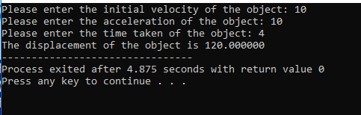

# **Question #6**

#include <stdio.h>

#include <math.h>

int main(){

//Q6

float r;

const float pi = 3.142;

printf("Please enter radius of the sphere: ");

scanf("%f", &r);

printf("The volume of the sphere is = %f", (1.333333) * (pi * pow(r,3)));

float P;

float R;

float t;

float CP;

printf("\n\nPlease enter principle amount: ");

scanf("%f",&P);

printf("Please enter interest rate: ");

scanf("%f", &R);

printf("Please enter time: ");

scanf ("%f",&t);

CP = P * pow(1+(R/100),t);

printf("The compound interest over %.1f years is = %f", t,CP);

}

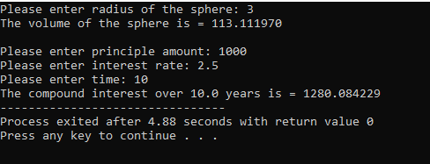

# **Question #7**

#include <stdio.h>

#include <math.h>

int main(){

//Q7

int UK = 10;

int US = 6;

int CHN = 4;

int AUS = 4;

printf("Julia had %d UK coins , %d US coins , %d Chinese coins , %d Australian coins.", UK,US,CHN,AUS);

printf("\nNow Julia has %d UK coins , %d US coins , %d Chinese coins , %d Australian coins.", UK-4,US-2,CHN-1);

}

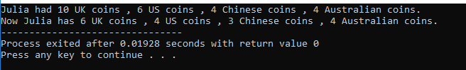

# **Question #8**

#include <stdio.h>

#include <math.h>

int main(){

//Q8

float weight_p,weight_kg,height_I,height_m;

printf("Please enter weight in pounds: ");

scanf("%f", &weight_p);

weight_kg = weight_p / 2.2046;

printf("Please enter height in inches: ");

scanf("%f", &height_I);

height_m = height_I * 0.0254;

printf("The weight in Kilograms is = %f", weight_kg);

printf("\nThe height in metres is = %f", height_m);

}

